* **Activity 3:**

### Using the DISTINCT Keyword

**Display the number of distinct countries available in the Flight table.**

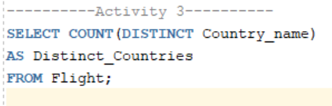

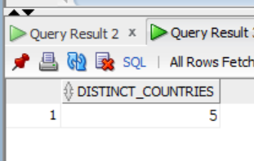Output: